Face Recognition example:

We will fetch the data from sklearn datasets, a fetcher is used to retrieve the data set



Print labels , dimensions and faces with there corresponding labels with matplotlib

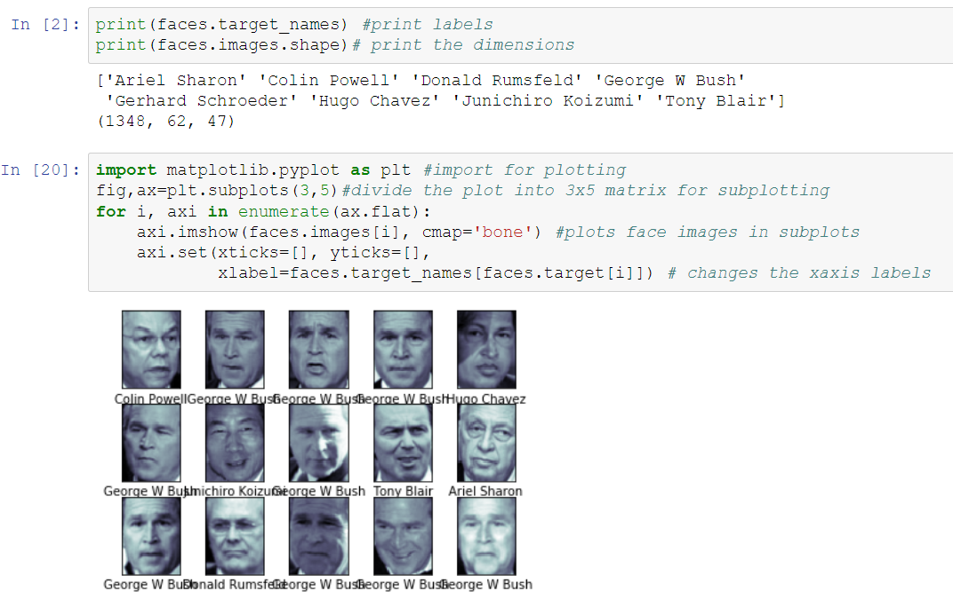

Apply PCA and SVM in pipeline to do the preprocessor and classifier into a single pipeline:

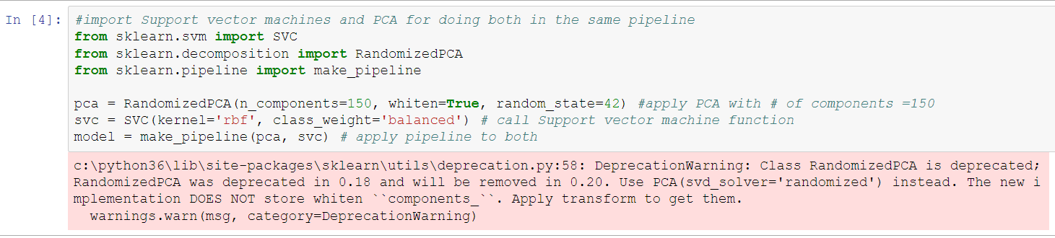

For testing split the data into test and training

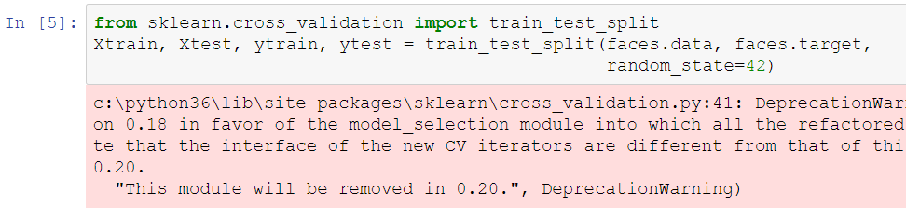

Use grid-search validation to explore best combination of C and gamma parameters for finding margin hardness and size of radial basis function

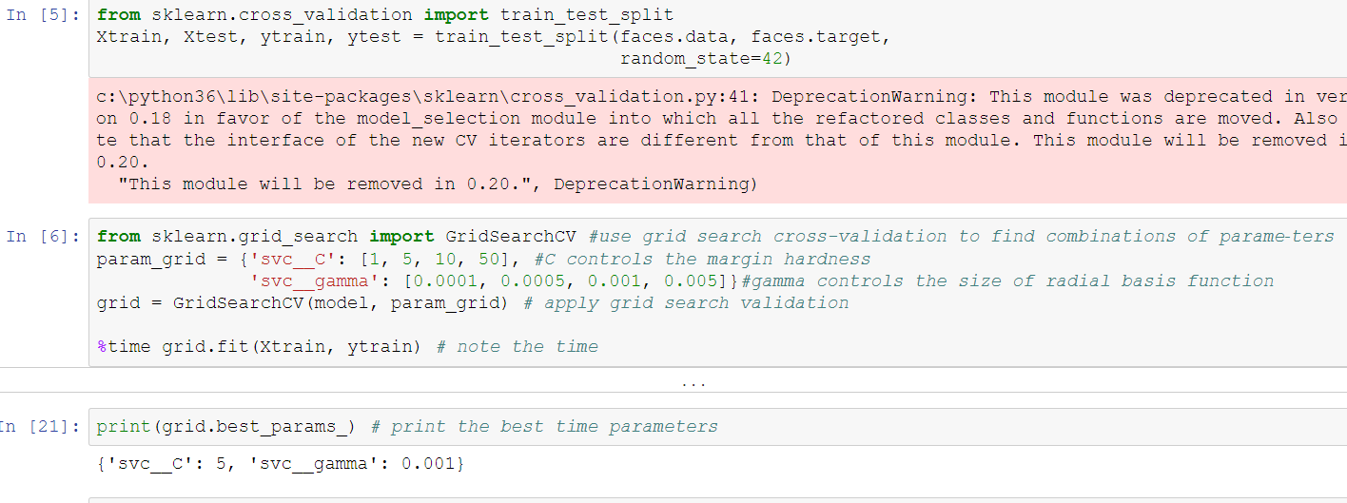

Now with this cross-validated model, we can predict the labels for the test data, which the model has not yet seen and look at a few of the test images along with their predicted values

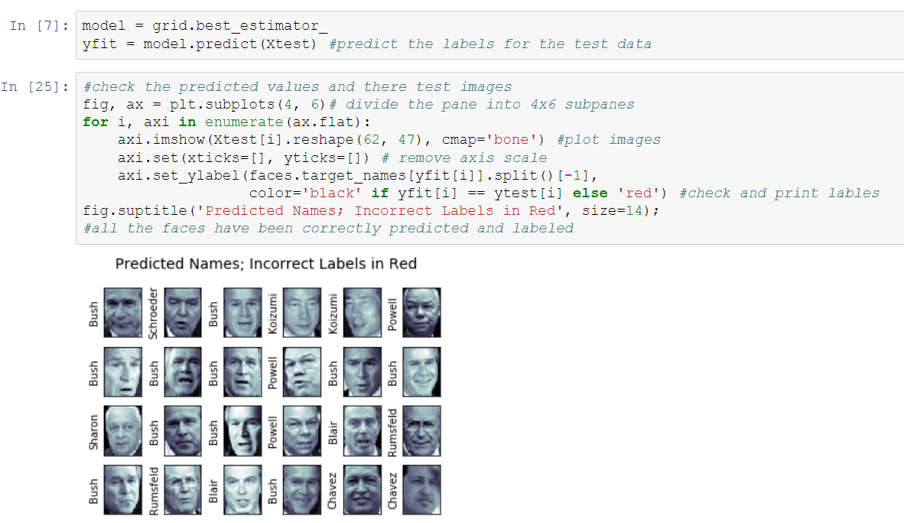

All the labels have been predicted correctly

We can print a classification report to further check on the accuracy of our results.

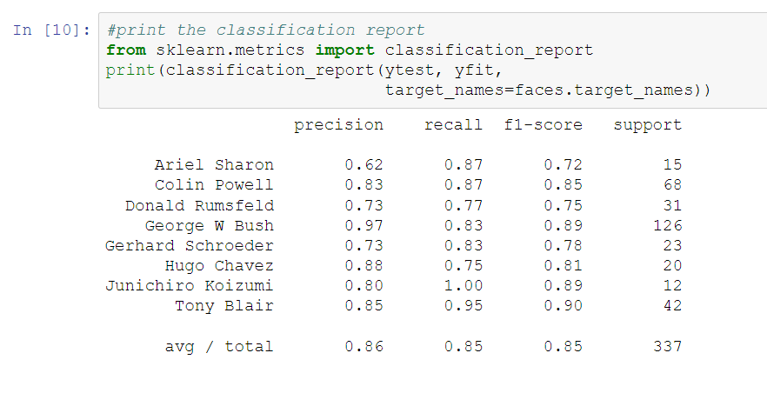

Printed below is the confusion matrix

